LEARNING WITH MY EYES EARS AND BODY...
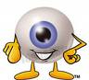
- What have you learned with your eyes in this unit?

- What have you learned with your ears?

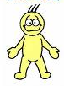
- What have you learned with your body?

