THE ART OF ASKING QUESTIONS
Read the paragraph below and look at the three types of questions we can ask about it.
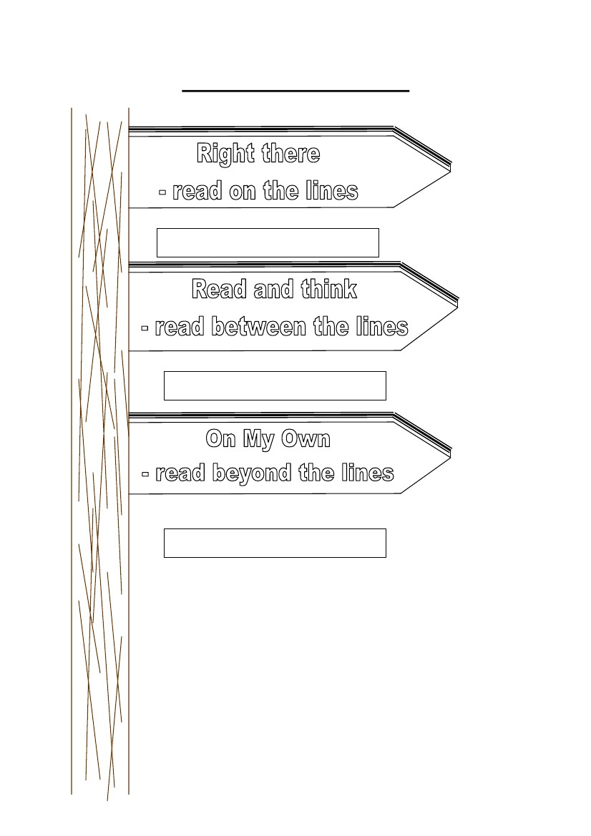
We all brought our pets to school yesterday as our teacher allowed us to do so. Wilson’s pet was so cute. It had white curly hair and big black eyes. It wagged its tail when we stroked its head but barked when we didn’t pay any attention to it. It bit my finger while I was playing with it; so, the teacher told Wilson to take it out of the classroom.

DID THE AUTHOR SAY IT?
The answer is in the story. It is
right there for you to read. You can
easily find it in a text.

For example: What color was the pet?

DID THE AUTHOR MEAN IT?
The answers can only be found by
searching for clues and inferring*
their meaning (*guessing or reading
between the lines).

For example: What sort of pet was it? How
do you know?

WOULD THE AUTHOR AGREE?
The answer won’t be told by words
in the story. You need to rely on your
personal knowledge and experience.

For example: Would you like to have a
pet like this?
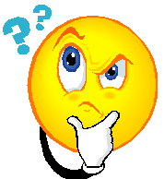
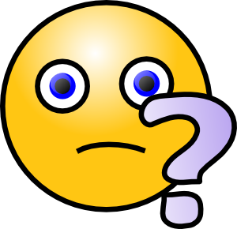
A-EACH QUESTION BELOW IS FROM A DIFFERENT GROUP OF QUESTIONS LISTED ON THE FIRST PAGE. WRITE A SHORT PARAGRAPH TO ANSWER THEM.
1-RIGHT THERE QUESTION:
Why is the forest in the story called ‘The Endless Forest?’

2-READ BETWEEN THE LINES QUESTION:
Sometimes authors or film directors use symbols to show a hidden meaning. For example, in a film or book bad weather may symbolize something bad is about to happen. In the story, "The Endless Forest" what do you think the forest symbolizes? Explain in detail.

3- READ BEYOND THE LINES QUESTION:

Do you think this is a good story? Did you enjoy readng it? Explain why/ why not giving specific examples from the story?

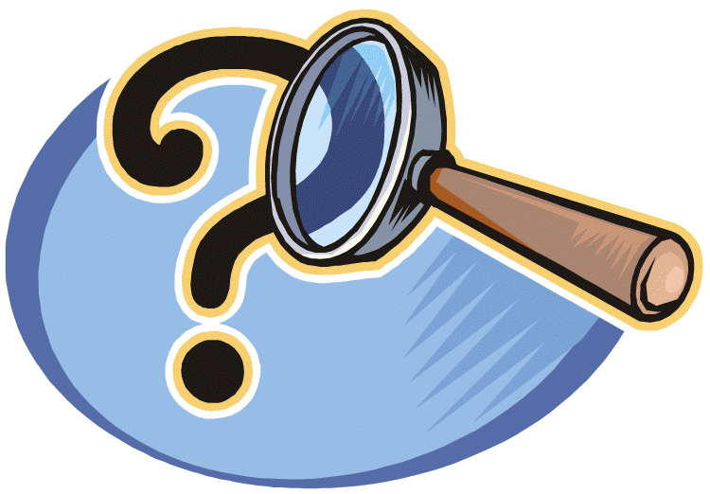
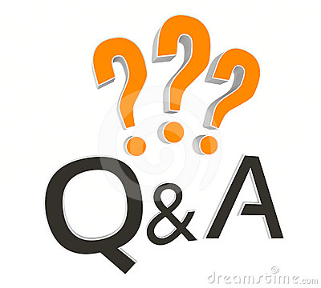

B- Now it’s your turn to ask questions about the story. Ask two questions from each group. We are going to give a worksheet about this story in the second term by choosing the best questions prepared by you when school starts
RIGHT THERE QUESTIONS:

READ BETWEEN THE LINES QUESTIONS:
1-

2-

READ BEYOND THE LINES QUESTIONS:

