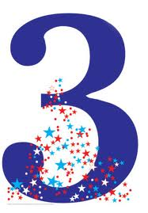
TELL ME THREE THINGS...

YOU LEARNED IN ENGLISH THAT YOU DIDN’T KNOW AT THE BEGINNING OF THIS TERM:
- ......................................................................

- ......................................................................

- ......................................................................

YOU HAVE LEARNED IN ENGLISH THIS TERM THAT YOU CAN USE IN OTHER SUBJECTS:
- ......................................................................

- ......................................................................

3- ......................................................................

TELL ME THREE THINGS...

YOU HAVE LEARNED IN ENGLISH THIS TERM THAT YOU WILL ALWAYS NEED / USE IN REAL LIFE:
- ......................................................................

- ......................................................................

- ......................................................................

YOU HAVE LEARNED IN ENGLISH THIS TERM THAT WILL HELP YOU BECOME A BETTER WRITER:
- ......................................................................

- ......................................................................

- ......................................................................

